A REAL TIME, RESOLUTION-AGNOSTIC AI FRAMEWORK FOR ENHANCED GLIOMA DETECTION AND SEGMENTATION

1st Narisetty SrinivasaRao
Department of Computer Science and Engineering
Lakireddy Bali Reddy College of Engineering (Autonomous)
Mylavaram, India
nsr543@gmail.com

4th Kalakonda Giridhara Venkata Krishna Sai
Department of Computer Science and Engineering
Lakireddy Bali Reddy College of Engineering (Autonomous)
Mylavaram, India
giridharak2301@gmail.com
2nd Chintada Yaswanth
Department of Computer Science and Engineering
Lakireddy Bali Reddy College of Engineering (Autonomous)
Mylavaram, India
chyaswanth890@gmail.com
3rd Kancharana Hari Prasad
Department of Computer Science and Engineering
Lakireddy Bali Reddy College of Engineering (Autonomous)
Mylavaram, India hariprasadkancharana@gmail.com

Abstract— Detection of Glioma is a severe process as it depends on Magnetic Resonance Imaging (MRI) scans. Checking of these scans manually takes so much of time and can lead to mistakes. To solve this problem, our study introduces a system which is a real-time, resolution agnostic framework for faster detection of glioma tumor using MRI images. This framework uses a modified VGG-16 backbone with parallel convolutional modules for feature extraction, along with YOLO-based detection head and an enhanced HDSA segmentation head. Resolution Agnostic Loss (RAL) a loss function is introduced to maintain quality across scans. When tested on the BraTS data collection, the model delivered strong precision at speed, suggesting it could help doctors assess cases quicker without losing reliability.
Keywords— Magnetic Resonance Imaging, VGG backbone, Glioma Detection, Deep Learning.

Introduction
Glioma is a type of brain tumor that develops from glial cells which is a dangerous and aggressive form of brain tumor. Generally, glioma is classifies based on its grade, which can range from low-grade Astrocytoma to high-grade glioblastoma. As they deeply blend with healthy areas, removing them completely becomes nearly impossible and spotting them early improves the accurate diagnosis [1].
The symptoms of glioma may depend on tumor size, location, and grade, which starts with regular headaches, seizures, fuzzy vision, trouble in thinking and a slight paralysis. As the things get worse, people personality changes, balance fades, steps become unsteady. These symptoms frequently overlap with other neurological disorders, making early diagnosis complex and unreliable without imaging support .
Identification of gliomas or ant brain related issue depend on Magnetic resonance imaging (MRI), since is shows soft-tissues clearly. MRI scans are of different types - like T1, T2, FLAIR, and contrast-enhanced scans provides layers of detail about the tumor shape, swelling and dead tissue around it. However, accurate interpretation of these scans requires expert radiological analysis and is time-intensive [2].
During the detection of glioma by manually looking at brain scans can lead to errors. By considering a small tissue sample, we can tell whether it needs surgery or not, which is risky. A doctor physical or mental condition and scans between doctors may also affect the results. This inconsistency makes consistent care hard to maintain across hospitals. So, tools that assist with image review start to make sense [3].
Recent advancement in deep learning have featured glioma detection and segmentation with high accuracy. Models like VGG, ResNet, U- Net, along with tuned hybrids, do well on standard test data. However, many of these models are computationally expensive and exhibit reduced performance when applied to low-resolution or noisy MRI scans.
The goal of this project is to design an efficient, real-time framework that overcomes resolution dependency and computational problems. This model focuses more on varying MRI scans by connecting the gap between experimental and clinical accuracy [5].
Many previous researches have done on deep learning-based glioma analysis. For more accurate segmentation, U-Net architecture is used by many researchers, for classification of these tumors it often relies on CNNs or ResNets - both show solid results [6]. YOLO based approaches have shown faster detection, and ensemble models have improved robustness at the cost of increased complexity, limiting real-time applicability.
The aim of this work is to propose a real time, resolution-agnostic, multi-task deep learning framework capable of detecting glioma, segmentation, grading, and explainability. In addition to that, by adding Resolution-Agnostic loss and a shared backbone, the proposed system seeks to deliver accurate, interpretable, and real-time glioma analysis to support radiologists in clinical decision-making [7].

Literature Survey
Researchers began showing how useful deep learning can be used in detection of brain tumors in MRI scans.
A. B. Abdusalomov, M. Mukhiddinov, and T. K. Whangbo introduced a system built on YOLOv7, used attention mechanisms and feature pyramids to improve tumor detection [8]. This method worked well identifying gliomas, meningiomas, and pituitary growths. However, detecting those tumors is very hard especially when the tumor size is small or quality of image varies.
A. A. Asiri, M. A. Alzahrani, S. A. Alshahrani, and S. A. Alqahtani proposed a fine-tuned CNN framework using ResNet50 with U-Net for simultaneous brain tumor classification and segmentation [9]. With data from TCGA-LGG and TCIA datasets, their model achieved high Dice similarity and Intersection. Though it has good accuracy, it relied on high – resolution MRI scans which are computationally expensive. This limits its real-time applicability in clinical environments with constrained computational resources.
In brain tumor detection using MRI scans S. Saeedi, S. Rezayi, H. Keshavarz, and S. R. N. Kalhori tested various deep learning models alongside standard machine learning approaches [10]. Instead of relying on one method, they examined a custom 2D CNN, a convolutional autoencoder, along with different classifier types. Performance-wise, their designed CNN outperformed older techniques in both accuracy and ROC metrics. Even though, the framework focused heavily on classification and failed on image clarity or explainability.
Chattopadhyay and Maitra presented a CNN-based brain tumor detection system combined with traditional classifiers such as SVM for validation [11]. Their model used a 2D MRI images having high accuracy with the help of deep learning over traditional process. However, the system relied on high quality MRI scans and required heavy preprocessing.
ZainEldin et al. designed a refined CNN model using Inception-ResNetV2 applying a sine-cosine fitness grey wolf optimization for hyperparameter tuning [12]. Their model performed very well on the BraTS dataset. As this process in optimization improved performance, the model suffered with some extra computation load. Also, this model did not explained segmentation and explainability, which are important for users.
M. N. Islam, M. M. Rahman, and M. A. Hossain proposed a model in which multiple CNN models are mixed, along with some LSTM combos, which crafted a system for identifying brain tumors [13]. This approach not only improved accuracy but also improved recall. However, as the number of layers increased, the model prediction becomes slower.
N. Rasool, M. A. Khan, A. Rehman, and S. Kadry proposed a system which is CNN-TumorNet, with LIME, helps to detect brain tumor [14]. The system has high accuracy also has explainability. However, it has only classification but there is no segmentation part.

Existing System
The existing system has various frameworks for detection and segmentation of tumor using machine learning and deep learning techniques. These methodologies can change in input, model complexity and importance.
• MRI Image-Based Deep Learning Analysis
• CNN and Transfer Learning–Based Models
• Segmentation based Architectures
• Explainability-Integrated Diagnostic Models
A. MRI Image-Based Deep Learning Analysis:
To detect and spot tumors using brain MRI scans we need some tools and deep learning techniques. While they work well, when the image clarity reduces or worse the performance get worse. [15]
B. CNN and Transfer Learning–Based Models:
The models such as VGG, ResNet or baseline CNNs can increase precision for detection of glioma. Though, these models require high processing power and focus mainly on sorting of tasks. [16]
C. Segmentation based Architectures:
By using MRI scans the standard way to identify tumors is by using U-Net like models. Though, these models lack real-time analysis and high computation power. But these are useful to detect sharp areas. [17]
D. Explainability-Integrated Diagnostic Models:
Tools such as Grad-CAM or LIME can reveal the decision-making process as it can cause delays. These tools also helps to explain the process of how decision is made.

Proposed System
To address the existing CNN approaches we propose a system which is a real-time, resolution-agnostic deep learning framework for glioma detection, segmentation and explainability using multimodal MRI images. Our system tries to address the limitations by adding adaptive learning within the architecture.

1. Modified VGG-16 Feature Extractor
VGG is a deep learning convolutional neural network-based architecture packed with multiple layers by using small kernels. By the help of parallel processing and removal of less useful connections, it detects features for identification of tumors across various efficiencies at same time. The extracted features are sent to model training.
The convolution operation is defined as:
$$\begin{matrix} & F_{k}(x,y)=\sum_{i=1}^{m}{\sum_{j=1}^{n}{I(x+i,y+j)⋅}}W_{k}(i,j)+b_{k} & & \text{(1)}\end{matrix}$$Where:
- $F_{k}(x,y)$: Output feature map value at spatial position $\left(x , y\right)$for the $k^{th}$ filter.
- $I(x,y)$: Image input or image feature map.
- $W_{k}(i,j)$: Weight of the $k^{th}$convolution filter at position $\left(i , j\right)$
- $b_{k}$: Bias associated with the $k^{th}$filter
The modified VGG-16 feature extractor uses an alternative design to conventional VGG-16 as its implementation uses parallel convolutional modules to extract features across multiple scales. The redundant fully connected layers are removed to reduce parameter complexity and computational overhead. The feature extractor is also used as a backbone to support detection, segmentation and explainability.
2. ReLU Activation Function
Once convolution finishes, signals pass through a ReLU layer to add nonlinear behavior. This step allows detection of intricate tumor structures while reducing the risk of shrinking gradients during training. Feature map size shrinks through pooling, keeping key details intact. To hold onto major signs of tumors, max pooling finds use here instead.
$$\begin{matrix} & \text{ReLU}(z)=max⁡(0,z) & & \text{(2)}\end{matrix}$$
Where:
- $z$: Input value to the activation function (output of convolution)
- $max⁡(0,z)$: Returns $z$if positive, otherwise returns 0
3. Pooling Operation
Pooling layers are used to reduce the spatial dimensions of feature maps while preserving the most important information. Max pooling is employed in the proposed system to retain dominant tumor-related features.
$$\begin{matrix} & P(x,y)=\underset{(i,j)∈R}{max⁡}F(x+i,y+j) & & \text{(3)}\end{matrix}$$
Where:
- $P(x,y)$: Output pooled feature map value
- $F(x,y)$: Input feature map before pooling
- $R$: Pooling region (e.g., $2×2$window)
4. Parallel Multi-Task Heads
From the VGG-16 backbone, refined features maps move into three separate heads which are parallelly executable:
a) Detection and Classification Head
A prediction module determines both tumor existence and type through a softmax system. For training, error measurement relies on categorical cross-entropy as the cost function.
$$\begin{matrix} & L_{cls}=-\sum_{c=1}^{C}{y_{c}}log⁡({\hat{y}}_{c}) & & \text{(4)}\end{matrix}$$
Where:
- $L_{cls}$: Classification loss
- $y_{c}$: Ground truth label for class $c$(1 if correct, else 0)
- ${\hat{y}}_{c}$: Predicted probability for class $c$
b) Segmentation Head
A single pixel at a time gets labelled inside tumors by a system that adjusts for cell density. To manage uneven label distribution across images, the model uses Dice loss instead of standard error measures.
$$\begin{matrix} & L_{seg}=1-\frac{2∣P∩G∣}{∣P∣+∣G∣} & & \text{(5)}\end{matrix}$$
Where:
- $L_{seg}$: Segmentation loss
- $∣P∩G∣$: Intersection of predicted and actual tumor regions
- $∣P∣$, $∣G∣$: Total number of pixels in prediction and ground truth
5. Resolution-Agnostic Loss (RAL) function:
The proposed Resolution-Agnostic Loss (RAL) function dynamically adapts the training objective based on input MRI quality. The total loss is formulated as:
$$L_{total}=w_{q}L_{cls}+(1-w_{q})L_{seg}+λL_{density}$$where:
- $L_{cls}$→ YOLO-based classification/detection loss
- $L_{seg}$→ HDSA segmentation loss
- $L_{density}$→ feature-density regularization
- $w_{q}$→ adaptive weight based on image quality metric $q$(PSNR / entropy)
For high resolution scans, $w_{q}$ is low, as the system starts to focus more on segmentation head which helps to find better tumor boundaries. For low resolution scans, $w_{q}$ is high, the system starts to focus more on classification head while dealing with less visible elements.

Dataset
In this paper, we have used the Brain Tumor Segmentation (BraTS) 2024 dataset, which was obtained from Kaggle. This dataset consists of around 2,130 MRI scans which are brain tumor images. Since the MRI contain different modalities like T1, T2, FLAIR and T1CE it captures those at the start. Each scan offers detailed views across different tissue types, enabling precise boundary detection. Because manual annotations mark every tumor zone at pixel level, comparisons stay tightly grounded in human expertise. Prior to training, preprocessing adjusts spatial scales, removes non-brain tissues, then standardizes intensity values uniformly. To mimic variability seen in lower-quality acquisitions, artificially downscaled versions are introduced during model exposure.
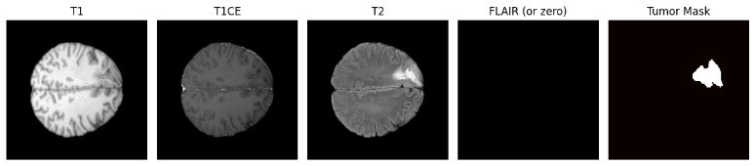
Fig. 1. Brain Slices
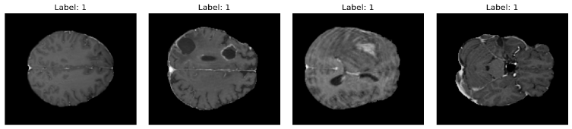
Fig. 2. Brain MRI Images.
Preprocessing:
Preprocessing is a crucial process which improves model performance, image quality and data consistency. In the following framework, the following pre- processing steps are used:
1. Intensity Normalization
As the MRI scans varies from machine to machine and country to country, intensity normalization helps to rescale the values to fixed range.
$$x_{\text{norm}}=\frac{x-x_{min}}{x_{max}-x_{min}}$$
where:
- $x$is the original pixel intensity,
- $x_{min}$and $x_{max}$are the minimum and maximum intensity values in the image.
The range should be in [0,1].

2. Mean–Variance Standardization:
This technique is used to reduce the intensity across the MRI scans
$$x_{\text{std}}=\frac{x-μ}{σ}$$
where:
- $μ$is the mean pixel intensity,
- $σ$is the standard deviation.
3. Noise Removal
Sometimes, MRI scans may capture unwanted signals. For this problem, Gaussian smoothing is applied.
$$G(x,y)=\frac{1}{2πσ^{2}}e^{-\frac{x^{2}+y^{2}}{2σ^{2}}}$$4. Skull Stripping:
This process removes fatty skin; skull part is removed. What remains is the brain area, which can go for analysis.
$$I_{\text{brain}}=I⋅M$$
where:
- $I$is the original MRI image,
- $M$is a binary brain mask.
5. Image Resizing
Since our VGG-16 model takes constant image size across all MRI images, image resizing technique is applied:
$$I^{'}(x^{'},y^{'})=I(αx^{'},βy^{'})$$where:
- $α$and $β$are scaling factors.
6. Feature Augmentation:
To improve the model performance and its capabilities data augmentation technique is used by adding images through rotations or flipping or cropping:
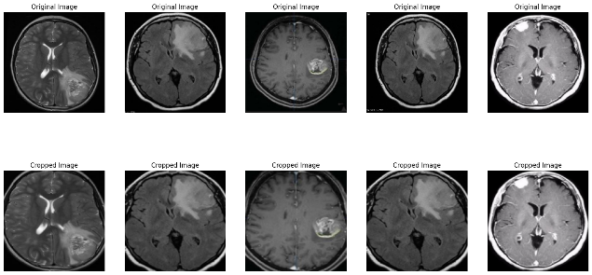
Fig. 3. Data Augmented Images.

RESULTS
Table I. BASELINE-CNN Model Performance Across Epochs.
BASELINE-CNN
Epochs | Performance Accuracy |  | Performance Loss
 | Training Accuracy | Validation Accuracy | Training Loss | Validation Loss
1 | 0.6587 | 0.56 | 0.6314 | 0.7161
2 | 0.6636 | 0.56 | 0.6118 | 0.7050
3 | 0.7974 | 0.60 | 0.4267 | 0.5973
4 | 0.8484 | 0.68 | 0.3571 | 0.5374
5 | 0.9185 | 0.84 | 0.2386 | 0.4231
6 | 0.9643 | 0.84 | 0.1774 | 0.4167
7 | 0.9719 | 0.84 | 0.1160 | 0.3754
8 | 0.9857 | 0.84 | 0.0698 | 0.4159
9 | 0.9785 | 0.84 | 0.0807 | 0.4006
10 | 0.9912 | 0.80 | 0.0388 | 0.4637
Table II. VGG - 16 Model Performance Across Epochs
VGG-16
Epochs | Performance Accuracy |  | Performance Loss
 | Training Accuracy | Validation Accuracy | Training Loss | Validation Loss
1 | 0.637475 | 0.55 | 0.642475 | 0.678875
2 | 0.714275 | 0.67 | 0.531650 | 0.601000
3 | 0.746975 | 0.74 | 0.480125 | 0.543325
4 | 0.849375 | 0.84 | 0.372900 | 0.380075
5 | 0.869150 | 0.85 | 0.313300 | 0.337925
6 | 0.888275 | 0.88 | 0.290825 | 0.286575
7 | 0.924000 | 0.83 | 0.190250 | 0.401275
8 | 0.961325 | 0.92 | 0.135725 | 0.238600
9 | 0.954326 | 0.91 | 0.100498 | 0.235640
10 | 0.973325 | 0.92 | 0.080175 | 0.235550
11 | 0.973050 | 0.91 | 0.082400 | 0.225700
12 | 0.971175 | 0.92 | 0.091675 | 0.215725
13 | 0.971954 | 0.93 | 0.086382 | 0.217680
14 | 0.970950 | 0.94 | 0.075350 | 0.228250
15 | 0.982625 | 0.94 | 0.067850 | 0.224250
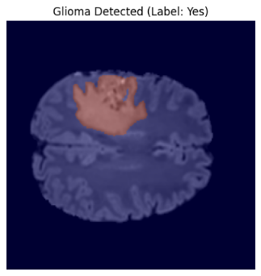

Fig. 4. Glioma Classification – Yes Predicted.

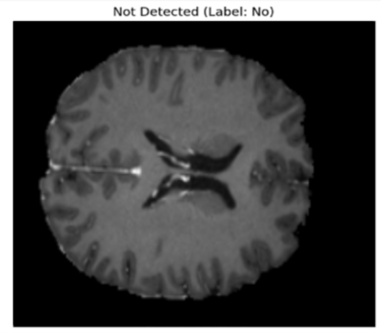

Fig. 5. Glioma Classification – No Predicted.
From the results we can see the models are performing well with good accuracies. During the training process, we can see that there is an increase in the training accuracy and validation accuracy and a decrease in training loss and validation loss in 15 epochs.
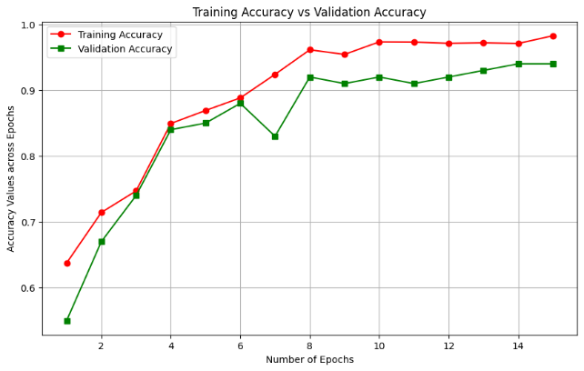
The model predicted images belongs to two different classes. They are: Yes and No which are used in testing phase. When the images for testing to the model the job of the model is to predict the images which class does it belongs to and understand the features correctly in the process of training. This analysis makes explainability easily in real-world clinical problems.
Fig. 6. Graph representing training and validation accuracy.
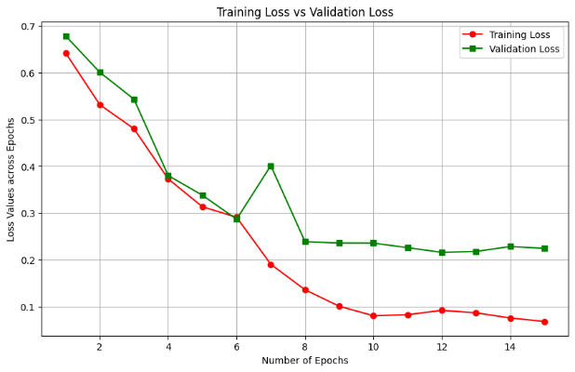
Fig. 7. Graph representing training and validation loss.
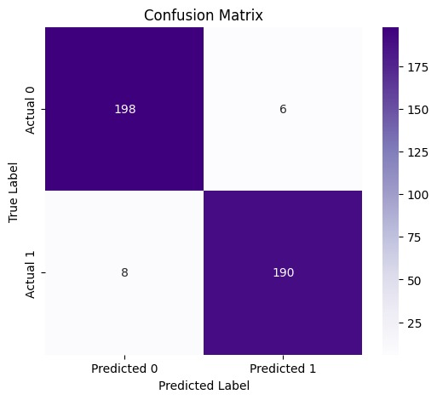
Fig. 8. Confusion Matrix.
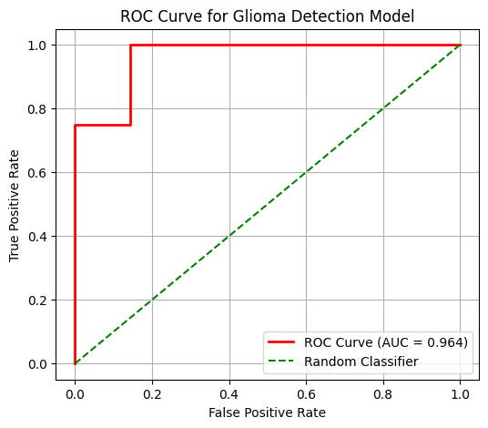
Fig. 9. Receiver Operating Characteristic (ROC) Curve.
The following graphs are the results of VGG-16 model tell us about the training accuracy and loss with validation accuracy and loss across 15 epochs. At the starting epochs, training accuracy starts at 0.63 at the end it reaches to 0.98 proving the model learnt features about the glioma. Coming to the validation accuracy, at the start of epochs, validation accuracy starts at 0.55 at last the accuracy reaches to 0.94 proving the model’s efficiency and ability to predict glioma which gives its significant increase in prediction rate and decrease in loss values makes the model is balanced and model can perform well when epochs are increased.
The framework was evaluated for segmentation performance using Dice Similarity Coefficient (DSC) and Intersection Over Union (IoU) metrics. The model achieved a score Dice Score of 0.93 and an IoU of 0.87 which resembles strong overlap between tumor predicted regions and ground truth. The model also achieved high precision of 0.94 and its recall of 0.92 which resulting in a few segmentation errors. These results tells us the improved HDSA segmentation head successfully detects tumors shapes at different MRI resolutions.

conclusion
Our study shows our project a real-time, resolution agnostic deep learning framework capable of detecting glioma, segmentation. Our model achieves high accuracy and explainability using VGG-16 using parallel convolutional heads. The model was able to detect features for detection and segmentation without the usage of heavy computation. This model will help in real-world clinical problems to achieve high accuracy by improving the classification by reducing the errors in manual process.

References
[1] V. Rajinikanth, S. Kadry, R. Damaševičius, R. A. Sujitha, G. Balaji, and M. A. Mohammed, “Glioma/glioblastoma detection in brain MRI using pre-trained deep-learning scheme,” in Proc. 3rd Int. Conf. Intelligent Computing Instrumentation and Control Technologies (ICICICT), Kannur, India, 2022, pp. 987–990, doi: 10.1109/ICICICT54557.2022.9917904.
[2] M. K. Abd-Ellah, A. I. Awad, H. F. A. Hamed, and A. A. M. Khalaf, “Parallel deep CNN structure for glioma detection and classification via brain MRI images,” in Proc. 31st Int. Conf. Microelectronics (ICM), Cairo, Egypt, 2019, pp. 304–307, doi: 10.1109/ICM48031.2019.9021872.
[3] H. A. Hafeez et al., “A CNN-model to classify low-grade and high-grade glioma from MRI images,” IEEE Access, vol. 11, pp. 46283–46296, 2023, doi: 10.1109/ACCESS.2023.3273487.
[4] P. C. Tripathi and S. Bag, “An attention-guided CNN framework for segmentation and grading of glioma using 3D MRI scans,” IEEE/ACM Transactions on Computational Biology and Bioinformatics, vol. 20, no. 3, pp. 1890–1904, May–Jun. 2023, doi: 10.1109/TCBB.2022.3220902.
[5] H. N. T. K. Kaldera, S. R. Gunasekara, and M. B. Dissanayake, “MRI-based glioma segmentation using deep learning algorithms,” in Proc. Int. Research Conf. Smart Computing and Systems Engineering (SCSE), Colombo, Sri Lanka, 2019, pp. 51–56, doi: 10.23919/SCSE.2019.8842668.
[6] R. Vinoth and C. Venkatesh, “Segmentation and detection of tumor in MRI images using CNN and SVM classification,” in Proc. Conf. Emerging Devices and Smart Systems (ICEDSS), Tiruchengode, India, 2018, pp. 21–25, doi: 10.1109/ICEDSS.2018.8544306.
[7] M. Rizwan, A. Shabbir, A. R. Javed, M. Shabbir, T. Baker, and D. Al-Jumeily Obe, “Brain tumor and glioma grade classification using Gaussian convolutional neural network,” IEEE Access, vol. 10, pp. 29731–29740, 2022, doi: 10.1109/ACCESS.2022.3153108.
[8] A. B. Abdusalomov, M. Mukhiddinov, and T. K. Whangbo, “Brain tumor detection based on deep learning approaches and magnetic resonance imaging,” Cancers, vol. 15, no. 16, p. 4172, Aug. 2023.
[9] A. A. Asiri, M. A. Alzahrani, S. A. Alshahrani, and S. A. Alqahtani, “Brain tumor detection and classification using fine-tuned CNN with ResNet50 and U-Net model,” Life, vol. 13, no. 7, p. 1449, Jun. 2023.
[10] S. Saeedi, S. Rezayi, H. Keshavarz, and S. R. N. Kalhori, “MRI-based brain tumor detection using convolutional deep learning methods and selected machine learning techniques,” BMC Medical Informatics and Decision Making, vol. 23, no. 114, 2023.
[11] A. Chattopadhyay and M. Maitra, “MRI-based brain tumor image detection using CNN-based deep learning method,” Neuroscience Informatics, vol. 2, p. 100060, 2022.
[12] H. ZainEldin, S. A. Gamel, E.-S. M. El-Kenawy, A. H. Alharbi, D. S. Khafaga, A. Ibrahim, and F. M. Talaat, “Brain tumor detection and classification using deep learning and sine-cosine fitness grey wolf optimization,” Bioengineering, vol. 10, no. 1, p. 18, Dec. 2022.
[13] M. N. Islam, M. M. Rahman, and M. A. Hossain, “An improved deep learning-based hybrid model with ensemble techniques for brain tumor detection from MRI images,” Informatics in Medicine Unlocked, vol. 47, p. 101483, 2024.
[14] N. Rasool, M. A. Khan, A. Rehman, and S. Kadry, “CNN-TumorNet: Leveraging explainability in deep learning for precise brain tumor diagnosis on MRI images,” Frontiers in Oncology, vol. 15, p. 1554559, 2025.
[15] T. L. Prasanthi and N. Neelima, “Improvement of brain tumor categorization using deep learning: A comprehensive investigation and comparative analysis,” Procedia Computer Science, vol. 233, pp. 703–712, 2024.
[16] Y. Bhanothu, A. Kamalakannan, and G. Rajamanickam, “Detection and classification of brain tumor in MRI images using deep convolutional network,” in Proc. 6th Int. Conf. Advanced Computing and Communication Systems (ICACCS), Coimbatore, India, 2020, pp. 248–252, doi: 10.1109/ICACCS48705.2020.9074375.
[17] F. B. Gonbadi and H. Khotanlou, “Glioma brain tumors diagnosis and classification in MR images based on convolutional neural networks,” in Proc. 9th Int. Conf. Computer and Knowledge Engineering (ICCKE), Mashhad, Iran, 2019, pp. 1–5, doi: 10.1109/ICCKE48569.2019.8965143.

